July 1, 2015

**Recommendation for Mr. Matthan Bird**

It is with great pleasure that I write this letter of recommendation for Mr. Matthan Bird. I have had the honor of getting to know Mr. Bird quite well over the course of the past eight years. We first met while he was enrolled at Schenectady County Community College (SCCC) in the Human Service – A.S. program. Mr. Bird graduated from SCCC in May 2012 and went directly on to University at Albany to complete his bachelors and beyond. Matthan Bird is a dynamic leader, a hard working individual, a valuable role model and a dedicated student. I recommend Mr. Matthan Bird with only the highest of regard.

Mr. Bird has demonstrated commitment to his academics and his outstanding performance reflects his impressive talents. In September 2010, he was hired to assist the Student Affairs Division as the Veteran’s Affairs Officer. During Mr. Bird’s two years on the job, he built a Veteran’s Affairs Office. He has done the most incredible job taking the various services that we have offered on campus previously and designed a solid program for our student Veterans. He connected our campus, not only with our own students, but with the community at large. The impact that Mr. Bird makes in the lives of Veteran’s continues to be seen every day. Under his support and guidance, the SCCC Student Veteran’s Office opened a national chapter of the Student Veterans of America Organization. Based on his dedication and commitment, Schenectady County Community College has been recognized as a ‘student Veteran friendly campus’.

Mr. Bird accepts all roles and responsibilities with a serious commitment and genuine pride. No matter what he takes on, changes are made and positive results are witnessed. He follows through on all details and meets all deadlines in advance. His organizational skills and communication skills are outstanding. The results of his dedicated labor are evident in all his recognitions, awards and successes.

Mr. Bird’s input, guidance and perspective are valued greatly. He does an exceptional job juggling his multiple responsibilities.  He is extremely organized, efficient, trustworthy and motivated.   Of all student leaders I have ever had the pleasure to work with; Mr. Bird is clearly in the top 5%.  He is an amazing, competent and confident individual. He sets a positive example for others while leading with a kind-heart and open mind. I have learned volumes from him. Few, if any, are in this same category of Mr. Bird.  He stands above and beyond in a field of academic excellence and outstanding leadership. I recommend Mr. Bird with the highest of regard.

Sincerely,

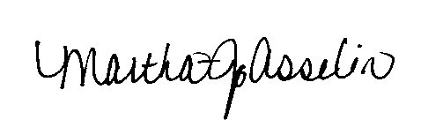

Martha J. Asselin, PhD

Vice President of Student Affairs